**22AIE303**

**LABSHEET - 8**

Name : **Anuvind M P**

Roll no. : **AM.EN.U4AIE22010**

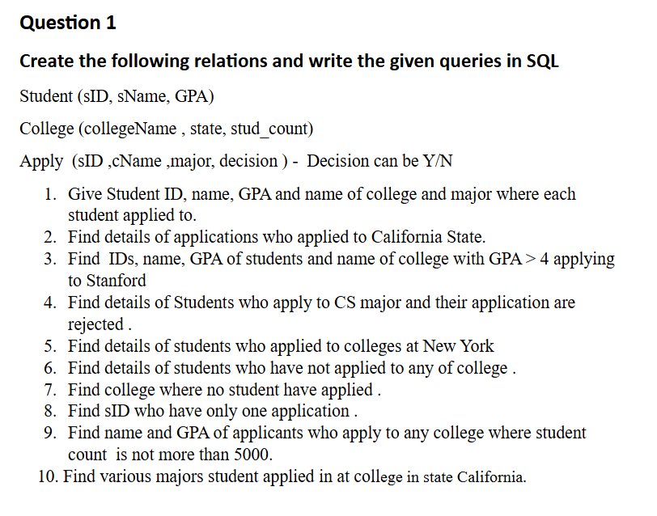

**CODE**

*CREATE TABLE Student_Lab8 (*

*sID INT PRIMARY KEY,*

*sName VARCHAR(50),*

*GPA DECIMAL(3, 2)*

*);*

*CREATE TABLE College_Lab8(*

*collegeName VARCHAR(50) PRIMARY KEY,*

*state VARCHAR(50),*

*stud_count INT*

*);*

*CREATE TABLE Apply_Lab8(*

*sID INT,*

*cName VARCHAR(50),*

*major VARCHAR(50),*

*decision CHAR(1),*

*PRIMARY KEY (sID, cName),*

*FOREIGN KEY (sID) REFERENCES Student_Lab8(sID),*

*FOREIGN KEY (cName) REFERENCES College_Lab8(collegeName)*

*);*

*-- -- Insert data into Student table*

*-- INSERT INTO Student_Lab8 VALUES (1, 'Alice', 3.9), (2, 'Bob', 4.2), (3, 'Charlie', 3.7),*

*-- (4, 'Diana', 4.5), (5, 'Eve', 3.8);*

*-- -- Insert data into College table*

*-- INSERT INTO College_Lab8 VALUES ('Stanford', 'California', 20000),*

*-- ('MIT', 'Massachusetts', 4500),*

*-- ('NYU', 'New York', 3000),*

*-- ('UCLA', 'California', 40000),*

*-- ('Columbia', 'New York', 5000);*

*-- -- Insert data into Apply table*

*-- INSERT INTO Apply_Lab8 VALUES*

*-- (1, 'Stanford', 'CS', 'Y'),*

*-- (2, 'Stanford', 'CS', 'Y'),*

*-- (2, 'MIT', 'CS', 'N'),*

*-- (3, 'NYU', 'Physics', 'Y'),*

*-- (3, 'Columbia', 'Math', 'Y'),*

*-- (4, 'UCLA', 'CS', 'N'),*

*-- (5, 'Columbia', 'CS', 'Y');*

*-- SELECT Student_Lab8.sID, sName, GPA, cName AS collegeName, major*

*-- FROM Student_Lab8*

*-- JOIN Apply_Lab8 ON Student_Lab8.sID = Apply_Lab8.sID;*

*-- SELECT Student_Lab8.sID, sName, GPA, cName, major, decision*

*-- FROM Student_Lab8*

*-- JOIN Apply_Lab8 ON Student_Lab8.sID = Apply_Lab8.sID*

*-- JOIN College_Lab8 ON Apply_Lab8.cName = College_Lab8.collegeName*

*-- WHERE College_Lab8.state = 'California';*

*-- SELECT Student_Lab8.sID, sName, GPA, cName AS collegeName*

*-- FROM Student_Lab8*

*-- JOIN Apply_Lab8 ON Student_Lab8.sID = Apply_Lab8.sID*

*-- WHERE GPA > 4 AND cName = 'Stanford';*

*-- SELECT Student_Lab8.sID, sName, GPA, cName AS collegeName, major*

*-- FROM Student_Lab8*

*-- JOIN Apply_Lab8 ON Student_Lab8.sID = Apply_Lab8.sID*

*-- WHERE major = 'CS' AND decision = 'N';*

*-- SELECT Student_Lab8.sID, sName, GPA, cName AS collegeName, major*

*-- FROM Student_Lab8*

*-- JOIN Apply_Lab8 ON Student_Lab8.sID = Apply_Lab8.sID*

*-- JOIN College_Lab8 ON Apply_Lab8.cName = College_Lab8.collegeName*

*-- WHERE College_Lab8.state = 'New York';*

*-- SELECT \**

*-- FROM Student_Lab8*

*-- WHERE sID NOT IN (SELECT sID FROM Apply_Lab8);*

*-- SELECT collegeName*

*-- FROM College_Lab8*

*-- WHERE collegeName NOT IN (SELECT cName FROM Apply_Lab8);*

*-- SELECT sID*

*-- FROM Apply_Lab8*

*-- GROUP BY sID*

*-- HAVING COUNT(*) = 1;*

*-- SELECT DISTINCT Student_Lab8.sID, sName, GPA*

*-- FROM Student_Lab8*

*-- JOIN Apply_Lab8 ON Student_Lab8.sID = Apply_Lab8.sID*

*-- JOIN College_Lab8 ON Apply_Lab8.cName = College_Lab8.collegeName*

*-- WHERE stud_count <= 5000;*

*-- SELECT DISTINCT major*

*-- FROM Apply_Lab8*

*-- JOIN College_Lab8 ON Apply_Lab8.cName = College_Lab8.collegeName*

*-- WHERE state = 'California';*

**OUTPUT**

1.

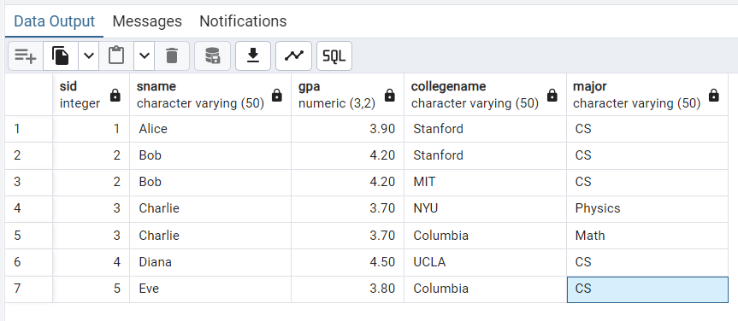

2.

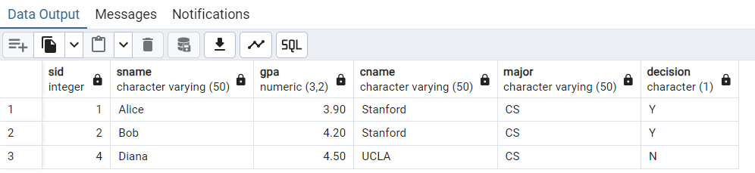

3.

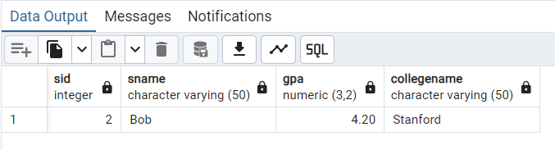

4.

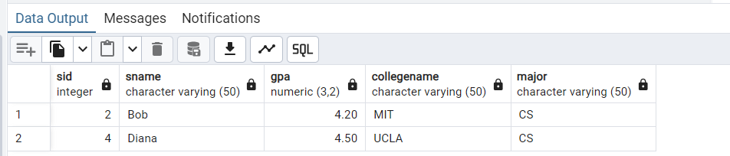

5.

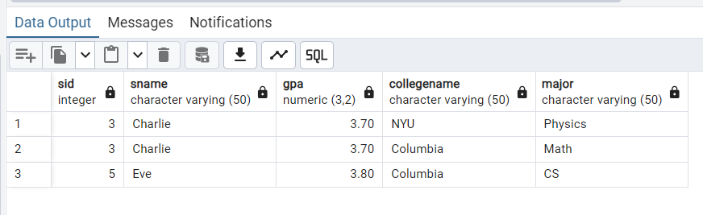

6.

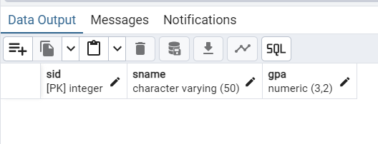

7.



8.

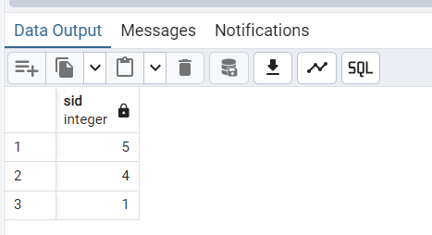

9.

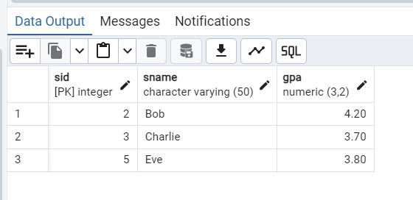

10.

